APPROVED BY:
G.Ciematnieks
Secretary General
Latvian Handball Federation

________________________

31.03.2017.
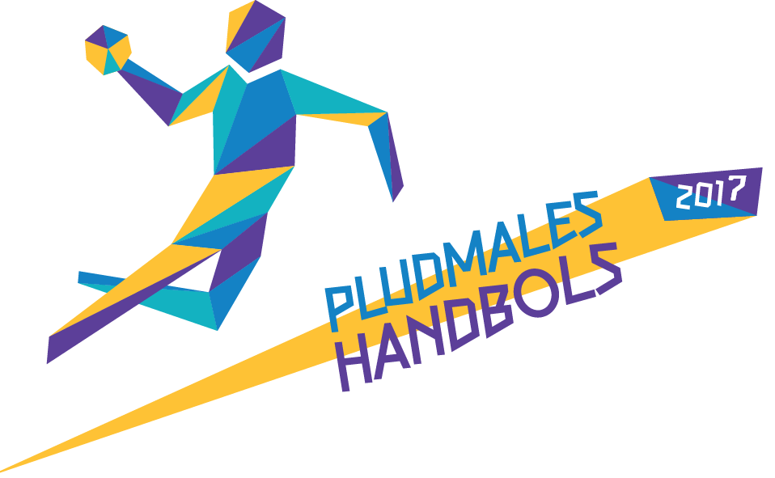

International Beach handball tournament "Jūrmala 2017"
REGULATIONS

I Target and tasks

- To popularise beach handball in the Baltic region, especially in Latvia.
- To encourage handball players to participate in physical activities during summer period.
- To determine which are the best beach handball teams in men and woman categories.

II Venue and date

- Tournament will take place in Jūrmala city, Majori beach stadium, Latvia from 1st to 2nd July of 2017.
- Tournament regulations and detailed information will be published in Latvian Handball Federation official homepage: www.handball.lv, www.facebook.lv, www.twitter.lv, http://www.jurmala.lv/.
III Organizers

- Tournament is organized by Latvian Handball Federation in cooperation with Local government of Jūrmala city.
- Tournament coordinator Renārs Līcis, phone number: +37129107103, e-mail renarslicis@inbox.lv

IV Participants

- Participants from Latvia and other countries aged above 15 years, can participate in the tournament.
- Men and women teams are going to play in separate categories.
- Players from foreign handball clubs, are responsible for their own security and health insurance during the tournament.
- Team must consist of at least 6 players and not more than 10 players.
- Player can participate only in one team during the tournament.
- Players must be dressed in the same coloured uniforms with numbers on them.

V System of the competitions

- System of the competition will be decided depending on the number of teams that obtained right to participate.
- Winning team is rewarded with 2 points, losing team is rewarded with 0 points.
- The ranking in the table will be decided according to the total amount of points each team has gained.
- If two or more teams have gained the same number of points the following ranking system is used:
  - results in points between the teams concerned;
  - difference between winning and losing periods the teams concerned;
  - goal difference in matches between the teams concerned;
  - difference between winning and losing periods in all matches;
  - greater count of winning periods in all matches;
  - goal (points) difference in all matches;
  - greater number of goals obtained in all matches.
- The Latvian team who is ranked in the highest position at the end of tournament, is permitted to represent Latvia in Europe beach handball tournament.

VI Applications

- Sign up for tournament till 31.05.2017. or 28.06.2017, sending application form (1st attachment) electronically via e-mail janis@handball.lv. Application of official team list (2nd attachment) needs to be handed in to tournament organizers before the start of the competition.

VII Financial regulations

- Signing up and making payment till 31.05.2017. entrance fee for team is 150,- EUR, signing up till 28.06.2017. entrance fee for team is 200,- EUR.
- Entrance fee has to be paid to the Latvian Handball Federation bank account with comment - Dalibas maksa Pludmales handbola turniram no 01.-02.07.2017.
LHF bank details:
Address: Lizuma iela 1, Rīga, LV-1006
Registration .nr.: 40008022078
Bank: Rietumu banka A/S
Code: RTMBLV2X
Account nr.: LV70RTMB0000067801920

- Participation in the competition are accepted after full payment of entrance fee.
- If the team obtained the right to participate in the tournament by making full payment of entrance fee and decides no longer take part in the competition, the entrance fee will not be refunded.
- Teams have responsibility for all personal expenses during the tournament.
- Teams and their players are responsible for their own safety and health matters during the tournament.

VIII Tournament rules

- Games are organized according to regulations of international beach handball.
- Beach handball rules are published in www.ihf.info and http://www.handball.lv/.

IX Referees

- All tournament games will be provided with Latvian and international referees.
- All protests can be submitted only by team official.
- Protest can be submitted in written form 10 minutes after the exact game making a security fee 50,- EUR.
- Protest is revised by tournament head-referee (submitted by LHF) immediately and decision is provided within 20 minutes.
- Security fee is returned if head-referee decision is in favour of protest submitter.
- Head-referee decision is not arguable.

X Prizes

- Tournament teams placed in 1st to 3rd position are granted with cups and money prizes:
 | 10 teams or more | 6-9 teams | Up to 5 teams
1.place | 1000,- EUR | 600,- EUR | 400,- EUR
2.place | 350,- EUR | 250,- EUR | -
3.place | 150,- EUR | 100,- EUR | -

XI Other rules

- If the player is disqualified with written report for unsportsmanlike conduct, he is banned from further tournament.
- If the team is breaking the rules of public order – team is disqualified from the tournament and is responsible to cover all costs and all material losses made by the team.
- Tournament organizers provide Physical Data Protection Act.

International beach handball tournament "Jūrmala 2017"

APPLICATION

Team name
Men or woman tournament
Club name
Address
Team representatives  data | Name |  | Surname
 | Phone nr. |  | e-mail

Date: _____________ Name, Surname_________________________________

Signature______________________________________

International beach handball tournament "Jūrmala 2017"

TEAM APPLICATION

Nr. | NAME | SURNAME | Birth date | Player nr.
1.
2.
3.
4.
5.
6.
7.
8.
9.
10.

Team official: ________ _____________________________
(signature) (name, surname)

